“I value your opinion… Not Really!”
EQ: How can we show value in a work of art?
Materials:
Pencil & eraser
12” x 18” white paper
Tempera paint
Plastic cups with lids
Round paint brushes

Resource: Art Images & Ideas, pp 26 & 27 and glossary
Project: Create a monochromatic color scheme painting.
Vocabulary: Using one color and adding white and black to create a value scale.
Procedure:
1: Draw a contour line drawing of PART of the arrangement. (See the example at the bottom.) Keep your composition relatively simple, leaving yourself a fairly large area of background.
2: Label the different areas of your drawing with the names of colors, tones, tints and shades you will paint with—this way, when you select a color, you can paint all of that color at the same time. This will help save paint. Make sure you use each color in at least two different areas in the painting, with the possible exception of your main background color.
3: Begin painting your picture using the one color you specified. Load only the tip of your brush—too much paint on the brush can make it hard to keep your lines neat. Check the painting area for colors that have already been mixed by other students and use those up before mixing others. When you need to mix colors, mix only a little at a time—maybe 3 squirts of paint out of the jugs. When you run out, get more.
All done? Take a picture of your artwork!
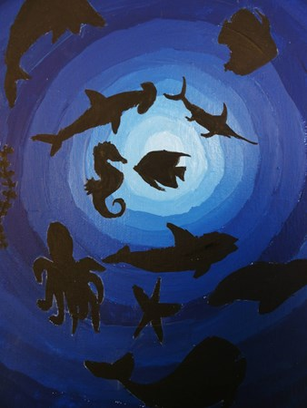
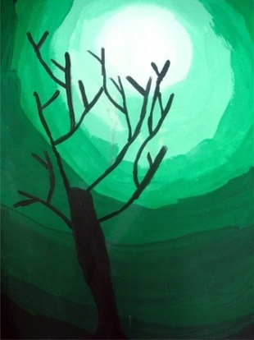
Student Samples:
GPS: VA8PR.3c. Examines, explores, and demonstrates understanding of basic color theory to create visual effects and communicate ideas.

